**SESHADRI RAO**

**GUDLAVALLERU ENGINEERING COLLEGE**

(An Autonomous Institute with Permanent Affiliation to JNTUK, Kakinada)

**Seshadri Rao Knowledge Village, Gudlavalleru.**

**Department of Computer Science and Engineering**

# MEAN STACK LAB

**PROGRAM 1:**

## Aim : Create a Database related to Hospital Management System and perform CRUD operations using MongoDB:

Please enter a MongoDB connection string (Default: mongodb://localhost/): Current Mongosh Log ID: 63e9b8a171f49fbdf26ee7eb

Connecting to:

mongodb://127.0.0.1:27017/?directConnection=true&serverSelectionTimeoutMS=2000&appN ame=mongosh+1.6.2

Using MongoDB: 6.0.3

Using Mongosh: 1.6.2

For mongosh info see: <https://docs.mongodb.com/mongodb-shell/>

The server generated these startup warnings when booting 2023-01-19T15:30:28.420+05:30: Access control is not enabled for the database. Read and write access to data and configuration is unrestricted.

Enable MongoDB's free cloud-based monitoring service, which will then receive and display metrics about your deployment (disk utilization, CPU, operation statistics, etc).

The monitoring data will be available on a MongoDB website with a unique URL accessible to you and anyone you share the URL with. MongoDB may use this information to make product improvements and to suggest MongoDB products and deployment options to you.

To enable free monitoring, run the following command: db.enableFreeMonitoring()

To permanently disable this reminder, run the following command: db.disableFreeMonitoring()

**Hospital Management System:**

**Creation of Database:**

test> use Hospital_Management_System

OUTPUT:switched to db Hospital_Management_System

## Creation of Doctor Collection:

Hospital_Management_System> db.createCollection("Doctor")

{ ok: 1 }

## Inserting Documents:

Hospital_Management_System>

db.Doctor.insertOne({'Did':1,'Dname':'raju','Qualification':'MBBS','Specalization':'Cardiologist','E xperience':10,'Patient_count':10})

OUTPUT: {

acknowledged: true,

insertedId: ObjectId("63f09fc5a269eed02afb1e0f")

}

Hospital_Management_System>

db.Doctor.insertOne({'Did':2,'Dname':'ravi','Qualification':'MBBS','Specalization':'Nephrologist',' Experience':10,'Patient_count':10})

{

acknowledged: true,

insertedId: ObjectId("63f0a041a269eed02afb1e10")

}

Hospital_Management_System>

db.Doctor.insertMany([{'Did':4,'Dname':'Srinu','Qualification':'MBBS','Specalization':'Pulmologist ','Experience':10,'Patient_count':10},{'Did':5,'Dname':'radha','Qualification':'MBBS','Specalizatio n':'Gynacologist','Experience':10,'Patient_count':10}])

{

acknowledged: true, insertedIds: {

'0': ObjectId("63f0a39ba269eed02afb1e12"),

'1': ObjectId("63f0a39ba269eed02afb1e13")

}

}

# Retrieving Documents:

Hospital_Management_System> db.Doctor.find({}) [

{

_id: ObjectId("63f09fc5a269eed02afb1e0f"), Did: 1,

Dname: 'raju', Qualification: 'MBBS',

Specalization: 'Cardiologist', Experience: 10,

Patient_count: 10

},

{

_id: ObjectId("63f0a041a269eed02afb1e10"), Did: 2,

Dname: 'ravi', Qualification: 'MBBS',

Specalization: 'Nephrologist', Experience: 10,

Patient_count: 10

},

{

_id: ObjectId("63f0a2fba269eed02afb1e11"), Did: 3,

Dname: 'gopi', Qualification: 'MBBS',

Specalization: 'Neurologist', Experience: 10,

Patient_count: 10

},

{

_id: ObjectId("63f0a39ba269eed02afb1e12"), Did: 4,

Dname: 'Srinu', Qualification: 'MBBS',

Specalization: 'Pulmologist', Experience: 10,

Patient_count: 10

},

{

_id: ObjectId("63f0a39ba269eed02afb1e13"), Did: 5,

Dname: 'radha', Qualification: 'MBBS',

Specalization: 'Gynacologist', Experience: 10,

Patient_count: 10

}]

# Limit fuction:

Hospital_Management_System> db.Doctor.find({'Dname':'gopi'}) [

{

_id: ObjectId("63f0a2fba269eed02afb1e11"), Did: 3,

Dname: 'gopi', Qualification: 'MBBS',

Specalization: 'Neurologist',

Experience: 10,

Patient_count: 10

}

]

Hospital_Management_System> db.Doctor.find({}).limit(2) [

{

_id: ObjectId("63f09fc5a269eed02afb1e0f"), Did: 1,

Dname: 'raju', Qualification: 'MBBS',

Specalization: 'Cardiologist', Experience: 10

Patient_count: 10

},

{

_id: ObjectId("63f0a041a269eed02afb1e10"), Did: 2,

Dname: 'ravi', Qualification: 'MBBS',

Specalization: 'Nephrologist', Experience: 10,

Patient_count: 10

}

]

# Updating Documents:

Hospital_Management_System>db.Doctor.updateOne({'Specalization':'Nephrologist'},{$set:{'Sp ecalization':'opthamologist'}

})

{

acknowledged: true, insertedId: null, matchedCount: 1,

modifiedCount: 1,

upsertedCount: 0

}

Hospital_Management_System> db.Doctor.find({'Did':2}) [

{

_id: ObjectId("63f0a041a269eed02afb1e10"), Did: 2,

Dname: 'ravi', Qualification: 'MBBS',

Specalization: 'opthamologist', Experience: 10,

Patient_count: 10

}

]

## Deleting Documents:

Hospital_Management_System> db.Doctor.deleteOne({'Did':5})

{ acknowledged: true, deletedCount: 1 }

## Deleting many Documents:

{ acknowledged: true, deletedCount: 1 }

Hospital_Management_System> db.Doctor.deleteMany({'Patient_count':10})

{ acknowledged: true, deletedCount: 4 }

Hospital_Management_System> db.Doctor.find({})

## List of Databases:

Hospital_Management_System> show dbs Hospital_Management_System 60.00 KiB

admin 40.00 KiB

config 108.00 KiB

local 72.00 KiB

local 72.00 KiB

## List of collections:

Hospital_Management_System> show collections Doctor

## Creation of Database:

test> use hmsc2

switched to db hmsc2

## Creation of Doctor Collection:

hmsc2> db.createCollection("Doctor")

{ ok: 1 }

## Inserting Documents:

hmsc2> db.Doctor.insertOne({'id':'d1','name':'ravi','specialization':'cardio','designation':'mbbs'})

{

acknowledged: true,

insertedId: ObjectId("63e9bb405b630ef3b047bf83")

}

hmsc2>

db.Doctor.insertOne({'id':'d2','name':'raju','specialization':'physio','designation':'chemist'})

{

acknowledged: true,

insertedId: ObjectId("63e9bbdd5b630ef3b047bf84")

}

hmsc2>

db.Doctor.insertOne({'id':'d3','name':'ramesh','specialization':'gynocologist','designation':'mbbs'

})

{

acknowledged: true,

insertedId: ObjectId("63e9bc3c5b630ef3b047bf85")

}

## Creation of Patient Collection:

hmsc2> db.createCollection("patient")

{ ok: 1 }

## Inserting Documents:

hmsc2>

db.patient.insertOne({'id':101,'name':'ramana','mobile':1234,'wardnumber':45,'visits':5,'OP date':11/2/22,'disease':'heartstroke'})

{

acknowledged: true,

insertedId: ObjectId("63e9c00f5b630ef3b047bf86")

}

hmsc2>

db.patient.insertOne({'id':102,'name':'max','mobile':3456,'wardnumber':45,'visits':3,'OP date':5/2/23,'disease':'tumor'})

{

acknowledged: true,

insertedId: ObjectId("63e9c0c45b630ef3b047bf87")

}

hmsc2>

db.patient.insertOne({'id':103,'name':'max','mobile':98765,'wardnumber':45,'visits':1,'OP date':15/2/23,'disease':'tooth ache'})

{

acknowledged: true,

insertedId: ObjectId("63e9c1385b630ef3b047bf88")

}

## Creation of Nurse Collection:

hmsc2> db.createCollection("nurse")

{ ok: 1 }

## Inserting Documents:

hmsc2> db.nurse.insertOne({'id':501,'name':'celena','docid':'d1','specilization':'nursing'})

{

acknowledged: true,

insertedId: ObjectId("63e9c40e5b630ef3b047bf89")

}

hmsc2> db.nurse.insertOne({'id':502,'name':'taylor','docid':'d2','specilization':'nursing'})

{

acknowledged: true,

insertedId: ObjectId("63e9c4785b630ef3b047bf8a")

}

hmsc2> db.nurse.insertOne({'id':503,'name':'andrea','docid':'d2','specilization':'bpharm'})

{

acknowledged: true,

insertedId: ObjectId("63e9c4c35b630ef3b047bf8b")

}

## CREATION OF OPERATION THEATRE COLLECTION:

hmsc2> db.createCollection("operation theatre")

{ ok: 1 }

## INSERTING DOCUMENTS:

hmsc2>

db.operationtheatre.insertOne({'pid':304,'did':'d1','surgerytype':'heart','surgerydate':21/3/22,'c ost':5000000})

{

acknowledged: true,

insertedId: ObjectId("63e9ca295b630ef3b047bf8c")

}

hmsc2>

db.operationtheatre.insertOne({'pid':304,'did':'d1','surgerytype':'heart','surgerydate':21/3/22,'c ost':5000000})

{

acknowledged: true,

insertedId: ObjectId("63e9cae55b630ef3b047bf8d")

}

hmsc2>

db.operationtheatre.insertOne({'pid':303,'did':'d2','surgerytype':'bypass','surgerydate':'21/3/22'

,'cost':600000})

{

acknowledged: true,

insertedId: ObjectId("63e9cb435b630ef3b047bf8e")

}

hmsc2>

db.operationtheatre.insertOne({'pid':302,'did':'d3','surgerytype':'apendisitis','surgerydate':'23/3

/22','cost':6000})

{

acknowledged: true,

insertedId: ObjectId("63e9cb8a5b630ef3b047bf8f")

}

## CREATION OF OPERATOR COLLECTION:

hmsc2> db.createCollection("operator")

{ ok: 1 }

## INSERTING DOCUMENTS :

hmsc2> db.operator.insertOne({'did':'d1','dname':'ravi','nurseid':501})

{

acknowledged: true,

insertedId: ObjectId("63e9cebf5b630ef3b047bf90")

}

hmsc2> db.operator.insertOne({'did':'d2','dname':'raju','nurseid':502})

{

acknowledged: true,

insertedId: ObjectId("63e9cef05b630ef3b047bf91")

}

hmsc2> db.operator.insertOne({'did':'d3','dname':'ramesh','nurseid':503})

{

acknowledged: true,

insertedId: ObjectId("63e9cf0c5b630ef3b047bf92")

}

## CREATE COLLECTION MEDICALCENTER:

hmsc2> db.createCollection("medicalcenter")

{ ok: 1 }

## INSERTING DOCUMENTS :

hmsc2>

db.medicalcenter.insertOne({'mid':901,'mname':'reddypharma','prid':801,'quantity':'500mg'})

{

acknowledged: true,

insertedId: ObjectId("63e9d4a05b630ef3b047bf93")

}

hmsc2> db.medicalcenter.insertOne({'mid':902,'mname':'appolo','prid':802,'quantity':'50mg'})

{

acknowledged: true,

insertedId: ObjectId("63e9d4d45b630ef3b047bf94")

}

hmsc2> db.medicalcenter.insertOne({'mid':903,'mname':'medplus','prid':803,'quantity':'60mg'})

{

acknowledged: true,

insertedId: ObjectId("63e9d4f65b630ef3b047bf95")

}

## OUTPUT IN MONGODB: COLLECTIONS IN HTMC2

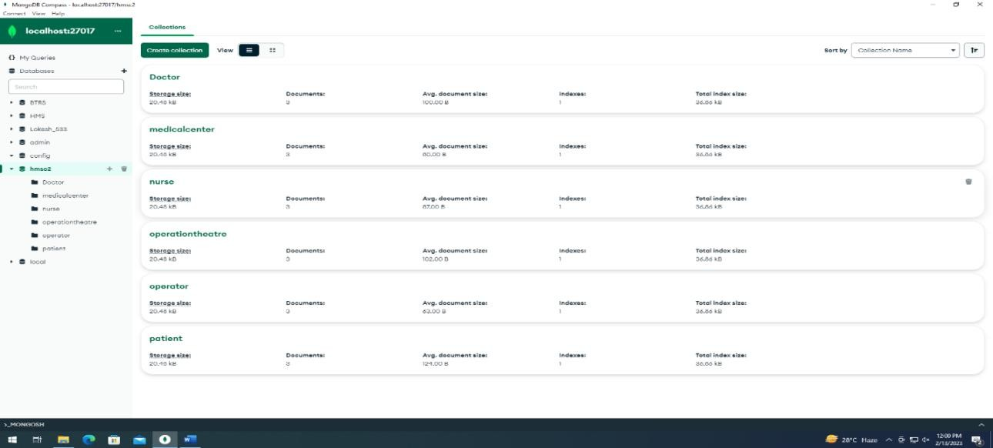

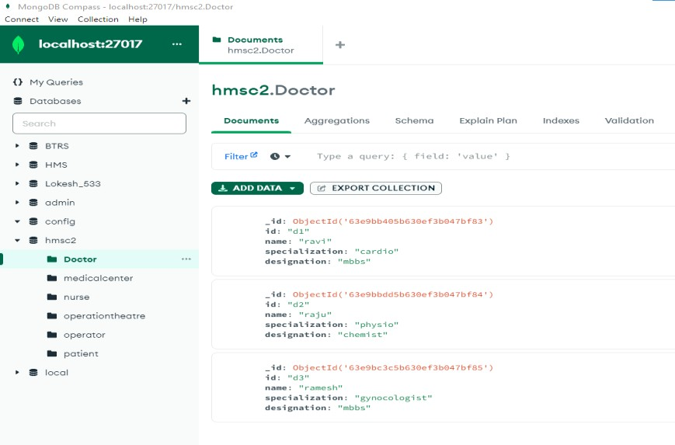**DOCTOR COLLECTION:**

## MEDICALCENTER COLLECTION:

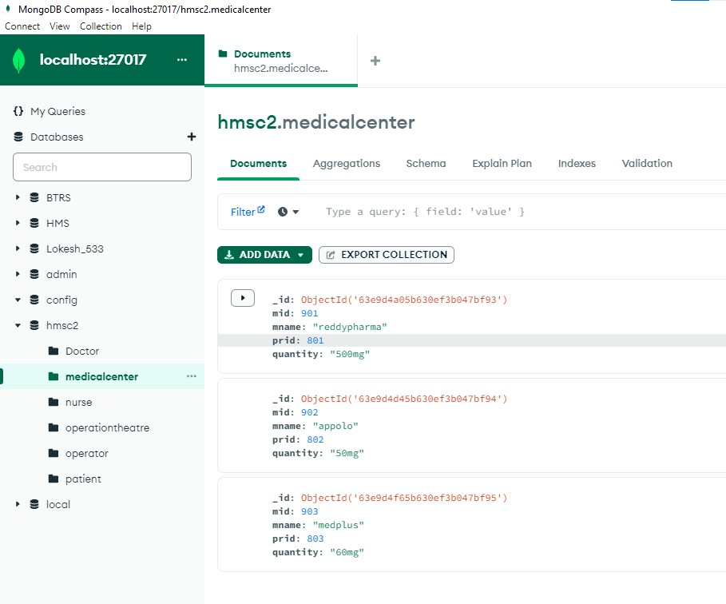

**NURSE COLLECTION:**

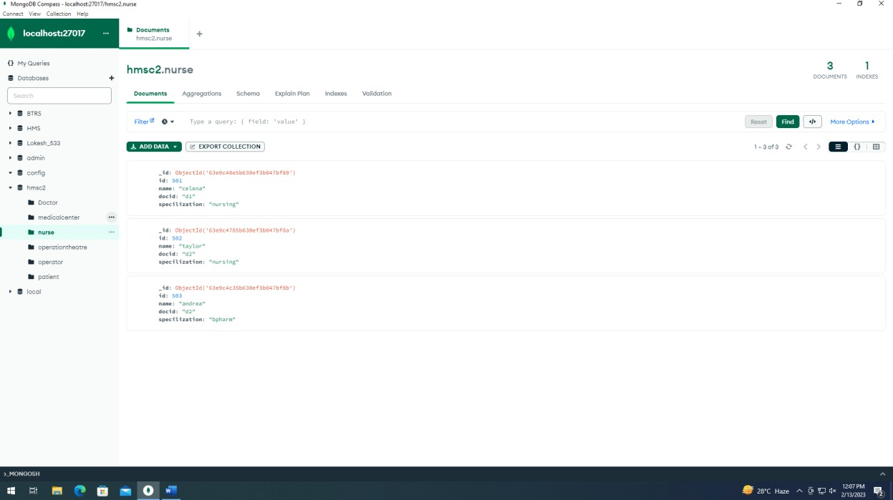

## OPERATIONTHEATRE COLLECTION:

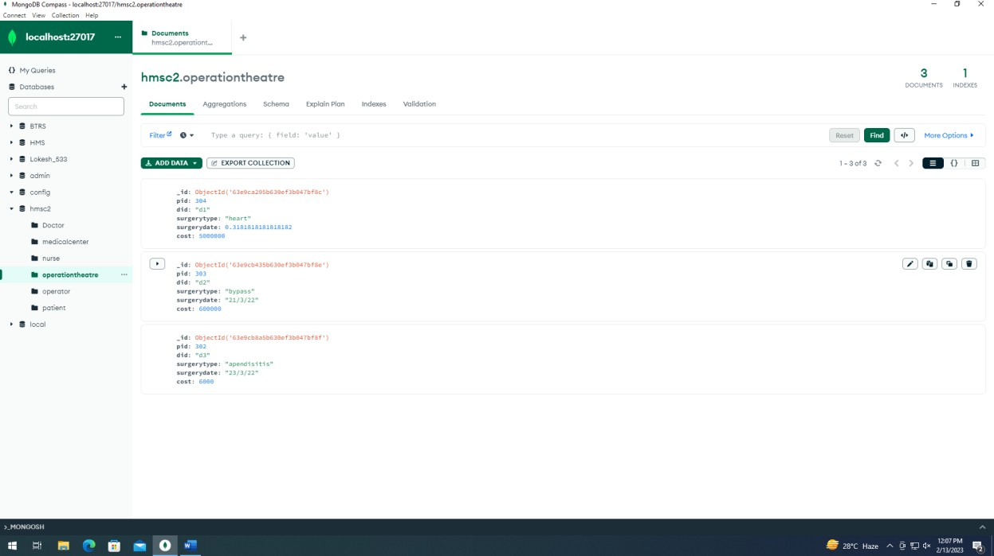

**PATIENT COLLECTION:**

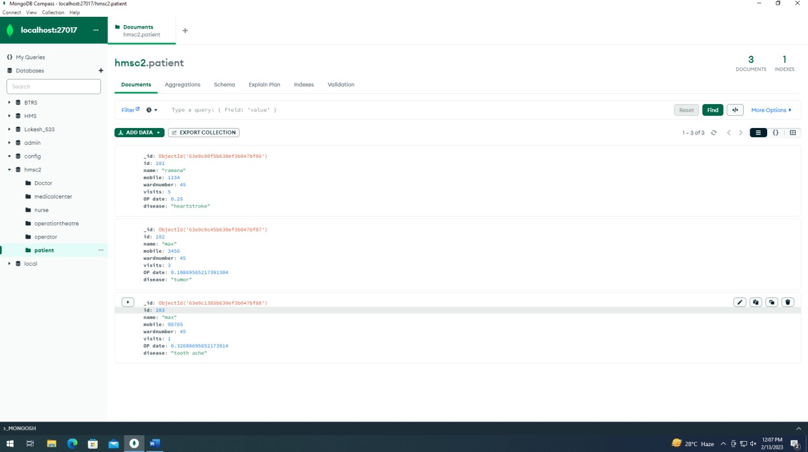

# PROGRAM2:

## Aim : Create a Database related to Bus Ticket Reservation System and perform CRUD operations using MongoDB:

**CREATION OF DATABASE:**

test> use BTRS

switched to db BTRS

## CREATE COLLECTION Drivers:

BTRS>db.createCollection("drivers")

{ ok: 1 }

## CREATE COLLECTION Bus:

BTRS> db.createCollection("bus")

{ ok: 1 }

## CREATE COLLECTION Passenger:

BTRS> db.createCollection("passenger")

{ ok: 1 }

## CREATE COLLECTION Transaction:

BTRS> db.createCollection("transaction")

{ ok: 1 }

## CREATE COLLECTION Depo:

BTRS> db.createCollection("depo")

{ ok: 1 }

## CREATE COLLECTION Source:

BTRS> db.createCollection("source")

{ ok: 1 }

## CREATE COLLECTION Destination:

BTRS> db.createCollection("destination")

## CREATE COLLECTION Tickets:

BTRS> db.createCollection("tickets")

{ ok: 1 }

## INSERTING DOCUMENTS:

1. **FOR Driver COLLECTION:**

BTRS>db.drivers.insertMany([{'driverId':'d887','busId':'b7765','drivername':'rambabu','driverpn o':'23/6'},{'driverId':'d088','busId':'b0765','drivername':'lokhnath','driverpno':'65-

90'},{'driverId':'d65','busId':'b507','drivername':'subbarao','driverpno':'20/6'}])

{

acknowledged: true, insertedIds: {

'0': ObjectId("63ec9d640f5a0d4d2f1497b3"),

'1': ObjectId("63ec9d640f5a0d4d2f1497b4"),

'2': ObjectId("63ec9d640f5a0d4d2f1497b5")

}

}

## FOR Bus COLLECTION:

BTRS>db.bus.insertMany([{'busId':'b998','busno':'Ap23Ay5464','seats':'76','depocity':'machilipat nam',’’driverId':'d887','to':'nellore','from':'machilipatnam'},

{'busId':'b065','busno':'Ap16Ay9866','seats':'77','depocity':'machilipatnam','driverId':'d085','to':' hyderabad','from':'machilipatnam'},

{'busId':'b99','busno':'Ap13Ay8876','seats':'90','depocity':'machilipatnam','driverId':'d097','to':'v ijayawada','from':'machilipatnam'}])

{

acknowledged: true, insertedIds: {

'0': ObjectId("63ec9e130f5a0d4d2f1497b6"),

'1': ObjectId("63ec9e130f5a0d4d2f1497b7"),

'2': ObjectId("63ec9e130f5a0d4d2f1497b8")

}

}

## FOR Ticket COLLECTION:

BTRS>db.ticket.insertMany([{'rId':'r554','busId':'b887','source':'machilipatnam','destination':'hyd erabad','pId':'p880','resdate':'13/3/2022','travellingdate':'16/3/2022','ticketnumber':'tap643','se atnumber':'sl123'},

{'rId':'r55','busId':'b87','source':'vizag','destination':'kurnool','pId':'p80','resdate':'13/3/2023','tra vellingdate':'14/3/2023','ticketnumber':'tasp143','seatnumber':'sl30'},

{'rId':'r904','busId':'b807','source':'vijayawada','destination':'hyderabad','pId':'p890','resdate':'10

/12/2022','travellingdate':'11/12/2022','ticketnumber':'tsp643','seatnumber':'sl023'}])

{

acknowledged: true, insertedIds: {

'0': ObjectId("63ec9fab0f5a0d4d2f1497b9"),

'1': ObjectId("63ec9fab0f5a0d4d2f1497ba"),

'2': ObjectId("63ec9fab0f5a0d4d2f1497bb")

}

}

## FOR Passenger COLLECTION:

BTRS>db.passenger.insertMany([{'pId':'p99','busno':'ap14Ay2232','pname':'sandeesh','age':21,'g ender':'male','phno':9122367601,'address':'gajuvaka,khaza','source':'machilipatnam','destinatio n':'nellore','ticketcost':'3000','seatnumber':'sl77'},

{'pId':'p855','busno':'ap16Ay2102','pname':'revathi','age':20,'gender':'female','phno':918484880 1,'address':'mudenepalli','source':'chirala','destination':'amaravathi','ticketcost':'9000','seatnum ber':'sp07'}])

{

acknowledged: true, insertedIds: {

'0': ObjectId("63eca1c80f5a0d4d2f1497bc"),

'1': ObjectId("63eca1c80f5a0d4d2f1497bd")

}

}

## FOR Depo COLLECTION:

BTRS>db.depo.insertMany([{'depoId':'dAp0866','deponame':'gajuvakadepo','location':'ameerpe t','busId':'b998','owner':'sandeesh'},

{'depoId':'dspp0878','deponame':'gunthagal','location':'kurnool','busId':'b018','owner':'praneet h'},

{'depoId':'dAp0916','deponame':'MGBS','location':'mgbs','busId':'b198','owner':'srinu'}])

{

acknowledged: true, insertedIds: {

'0': ObjectId("63eca3570f5a0d4d2f1497be"),

'1': ObjectId("63eca3570f5a0d4d2f1497bf"),

'2': ObjectId("63eca3570f5a0d4d2f1497c0")

}

}

## FOR Transaction COLLECTION:

BTRS>db.transaction.insertMany([{'paymentId':'paytm8866w23','pId':'p88','rId':'r655','transacti onDate':'20/11/2022','travellingDate':'25/11/2022'},

{'paymentId':'gpay7h7h9','pId':'p805','rId':'r605','transactionDate':'20/12/2020','travellingDate':' 25/12/2020'},

{'paymentId':'phonepe6x763','pId':'p808','rId':'r155','transactionDate':'10/10/2023','travellingD ate':'15/10/2023'}])

{

acknowledged: true, insertedIds: {

'0': ObjectId("63eca57b0f5a0d4d2f1497c3"),

'1': ObjectId("63eca57b0f5a0d4d2f1497c4"),

'2': ObjectId("63eca57b0f5a0d4d2f1497c5")

}

}

## FOR Source COLLECTION:

BTRS>db.source.insertMany([{'startDate':'23/12/2022','startTime':'9.00pm','sourceCity':'machili patnam'},

{'startDate':'21/11/2021','startTime':'10.00pm','sourceCity':'hyderabad'},

{'startDate':'3/10/2021','startTime':'7.00Am','sourceCity':'kurnool'}])

{

acknowledged: true, insertedIds: {

'0': ObjectId("63eca84f0f5a0d4d2f1497c6"),

'1': ObjectId("63eca84f0f5a0d4d2f1497c7"),

'2': ObjectId("63eca84f0f5a0d4d2f1497c8")

}

}

## FOR Destination COLLECTION:

BTRS>db.destination.insertMany([{'endDate':'3/2/2022','endTime':'1.00pm','destinationCity':'m achilipatnam'},

{'endDate':'1/9/2023','endTime':'10.30Am','destinationCity':'bhimavaram'},

{'endDate':'13/9/2021','endTime':'11.00Am','destinationCity':'vizag'}])

{

acknowledged: true, insertedIds: {

'0': ObjectId("63eca92a0f5a0d4d2f1497c9"),

'1': ObjectId("63eca92a0f5a0d4d2f1497ca"),

'2': ObjectId("63eca92a0f5a0d4d2f1497cb")

}

}

# Retrieving Documents Of Passenger:

BTRS> db.passenger.find() [

{

_id: ObjectId("63eca1c80f5a0d4d2f1497bc"), pId: 'p99',

busno: 'ap14Ay2232', pname: 'sandeesh', age: 21,

gender: 'male', phno: 9122367601,

address: 'gajuvaka,khaza', source: 'machilipatnam', destination: 'nellore',

ticketcost: '3000', seatnumber: 'sl77'

},

{

_id: ObjectId("63eca1c80f5a0d4d2f1497bd"), pId: 'p855',

busno: 'ap16Ay2102', pname: 'revathi',

age: 20,

gender: 'female', phno: 9184848801,

address: 'mudenepalli',

source: 'chirala',

destination: 'amaravathi', ticketcost: '9000',

seatnumber: 'sp07'

}

]

# Retrieving Documents Of Transcation With Specific ID:

BTRS> db.transaction.find({'paymentId':'paytm8866w23'}) [

{

_id: ObjectId("63eca4a70f5a0d4d2f1497c1"), paymentId: 'paytm8866w23',

pId: 'p88',

rId: 'r655',

transactionDate: '20/11/2022',

travellingDate: '25/11/2022'

},

{

_id: ObjectId("63eca4a70f5a0d4d2f1497c2"), paymentId: 'paytm8866w23',

pId: 'p7'

},

{

_id: ObjectId("63eca57b0f5a0d4d2f1497c3"), paymentId: 'paytm8866w23',

pId: 'p88',

rId: 'r655',

transactionDate: '20/11/2022', travellingDate: '25/11/2022'

}

]

## DELETE DOCUMENTS:

**BEFORE DELETING**: BTRS> db.depo.find() [

{

_id: ObjectId("63eca3570f5a0d4d2f1497be"), depoId: 'dAp0866',

deponame: 'gajuvakadepo', location: 'ameerpet',

busId: 'b998', owner: 'sandeesh'

},

{

_id: ObjectId("63eca3570f5a0d4d2f1497bf"), depoId: 'dspp0878',

deponame: 'gunthagal', location: 'kurnool',

busId: 'b018', owner: 'praneeth'

},

{

_id: ObjectId("63eca3570f5a0d4d2f1497c0"), depoId: 'dAp0916',

deponame: 'MGBS',

location: 'mgbs', busId: 'b198', owner: 'srinu'

}

]

## AFTER DELETE OPERATION:

##### >>>

BTRS> db.depo.deleteOne({'deponame':'kurnool'})

{ acknowledged: true, deletedCount: 0 }

##### >>>

BTRS> db.depo.deleteOne({'deponame':'gajuvakadepo'})

{ acknowledged: true, deletedCount: 1 }

## RETRIEVING DOCUMNETS:

BTRS> db.depo.find() [

{

_id: ObjectId("63eca3570f5a0d4d2f1497bf"), depoId: 'dspp0878',

deponame: 'gunthagal', location: 'kurnool',

busId: 'b018', owner: 'praneeth'

},

{

_id: ObjectId("63eca3570f5a0d4d2f1497c0"), depoId: 'dAp0916',

deponame: 'MGBS',

location: 'mgbs', busId: 'b198', owner: 'srinu'

}

]

## UPDATING DOCUMENTS:

##### >>>

**BEFORE UPDATION:**

BTRS> db.drivers.find() [

{

_id: ObjectId("63ec9d640f5a0d4d2f1497b3"), driverId: 'd887',

busId: 'b7765',

drivername: 'rambabu', driverpno: '23/6'

},

{

_id: ObjectId("63ec9d640f5a0d4d2f1497b4"), driverId: 'd088',

busId: 'b0765',

drivername: 'lokhnath', driverpno: '65-90'

},

{

_id: ObjectId("63ec9d640f5a0d4d2f1497b5"), driverId: 'd65',

busId: 'b507',

drivername: 'subbarao', driverpno: '20/6'

}

]

## UPDATE ONE:

BTRS> db.drivers.updateOne({'busId':'b7765'},{$set:{'busId':'b7'}})

{

acknowledged: true, insertedId: null, matchedCount: 1,

modifiedCount: 1,

upsertedCount: 0

}

## AFTER UPDATION:

BTRS> db.drivers.find() [

{

_id: ObjectId("63ec9d640f5a0d4d2f1497b3"), driverId: 'd887',

busId: 'b7',

drivername: 'rambabu', driverpno: '23/6'

},

{

_id: ObjectId("63ec9d640f5a0d4d2f1497b4"), driverId: 'd088',

busId: 'b0765',

drivername: 'lokhnath', driverpno: '65-90'

},

{

_id: ObjectId("63ec9d640f5a0d4d2f1497b5"), driverId: 'd65',

busId: 'b507',

drivername: 'subbarao', driverpno: '20/6'

}

]

## UPDATE MANY:

BTRS> db.transaction.updateMany({'pId':'p805'},{$set:{'pId':'p97','rId':'wew'}})

{

acknowledged: true, insertedId: null, matchedCount: 1,

modifiedCount: 1,

upsertedCount: 0

}

## AFTER UPDATION:

BTRS> db.transaction.find() [

{

_id: ObjectId("63eca4a70f5a0d4d2f1497c1"), paymentId: 'paytm8866w23',

pId: 'p88',

rId: 'r655',

transactionDate: '20/11/2022', travellingDate: '25/11/2022'

},

{

_id: ObjectId("63eca4a70f5a0d4d2f1497c2"), paymentId: 'paytm8866w23',

pId: 'p7'

},

{

_id: ObjectId("63eca57b0f5a0d4d2f1497c3"), paymentId: 'paytm8866w23',

pId: 'p88',

rId: 'r655',

transactionDate: '20/11/2022', travellingDate: '25/11/2022'

},

{

_id: ObjectId("63eca57b0f5a0d4d2f1497c4"), paymentId: 'gpay7h7h9',

pId: 'p97',

rId: 'wew',

transactionDate: '20/12/2020', travellingDate: '25/12/2020'

},

{

_id: ObjectId("63eca57b0f5a0d4d2f1497c5"), paymentId: 'phonepe6x763',

pId: 'p808',

rId: 'r155',

transactionDate: '10/10/2023', travellingDate: '15/10/2023'

}

]

## PROGRAM 3:

**Aim:Write node.js program to create, access, modify Arrays.**

## Installation of Node.js on Windows

**Step-1:** Downloading the Node.js ‘.msi’ installer.

The first step to install Node.js on windows is to download the installer. Visit the official Node.js website i.e) <https://nodejs.org/en/download/>and download the .msi file according to your system environment (32-bit & 64-bit). An MSI installer will be downloaded on your system.

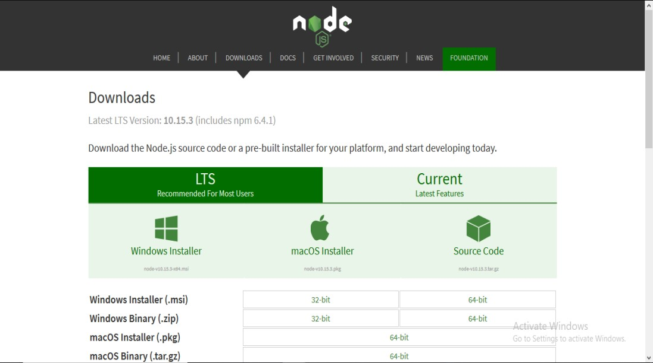

**Step-2:** Running the Node.js installer.

Now you need to install the node.js installer on your PC. You need to follow the following steps for the Node.js to be installed:-

* Double click on the .msi installer.

##### The Node.js Setup wizard will open.

* Welcome To Node.js Setup Wizard.

##### Select “Next”

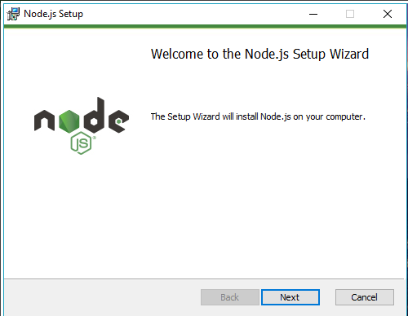

After clicking “Next”, End-User License Agreement (EULA) will open

##### Check “I accept the terms in the License Agreement”

**Select “Next”**

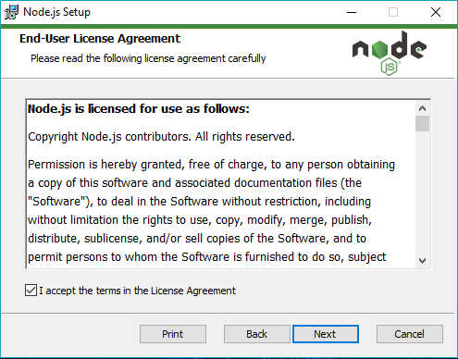

Destination Folder

**Set the Destination Folder where you want to install Node.js & Select “Next”**

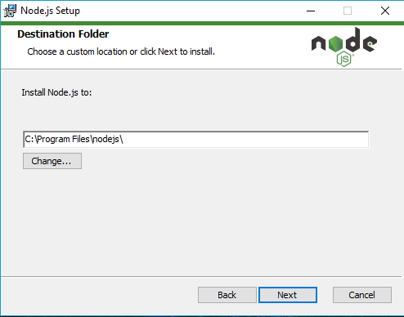

Custom Setup

**Select “Next”**

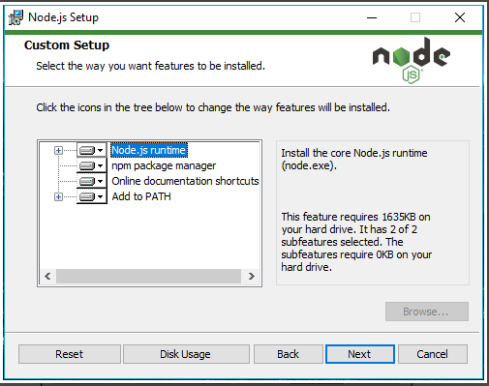

Ready to Install Node.js.

#### Select “Install”

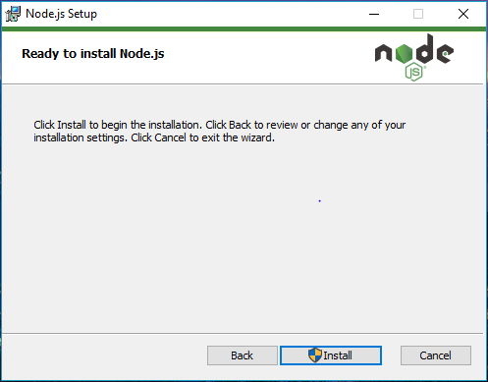

**Click “Finish”**

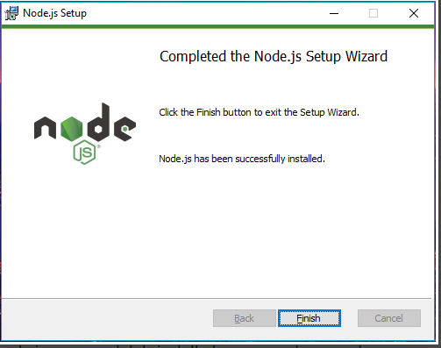

##### Step 3: Verify that Node.js was properly installed or not.

To check that node.js was completely installed on your system or not, you can run the following command in your command prompt or Windows Powershell and test it:-

##### C:\Users\Admin> node -v

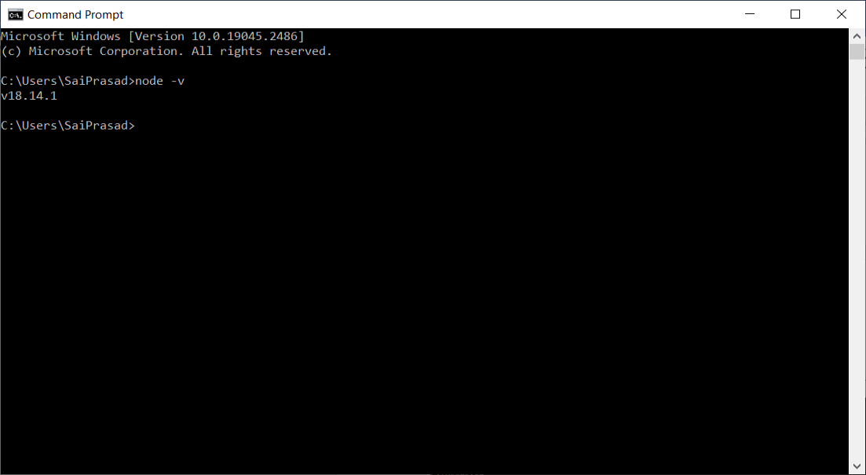

**Create Directory**

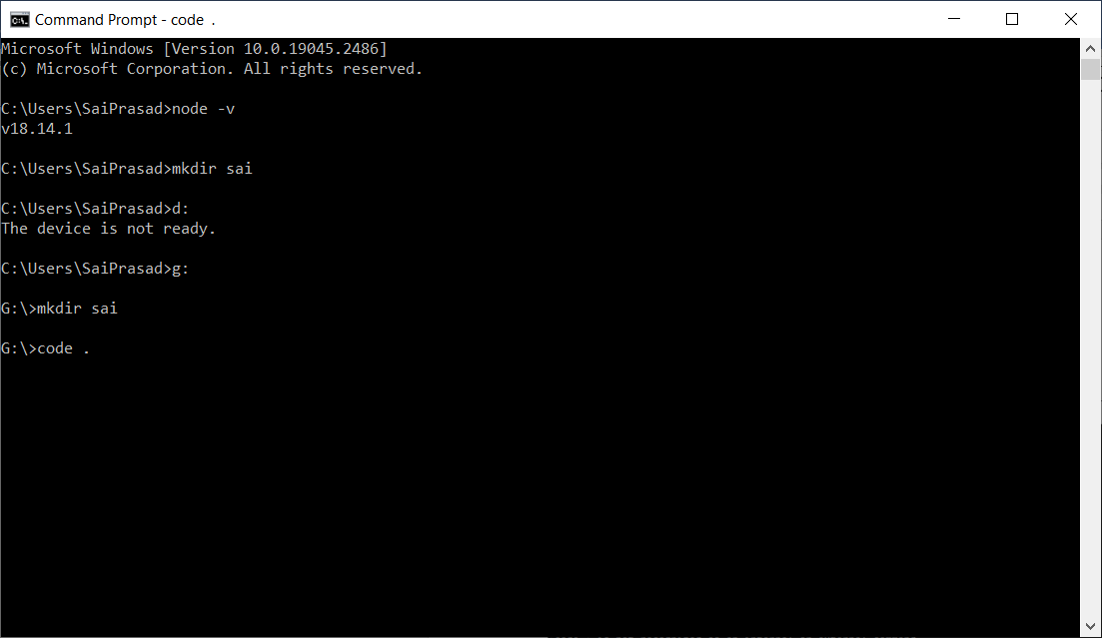

**Visual studio environment will be opened with the command code . “Enter”**

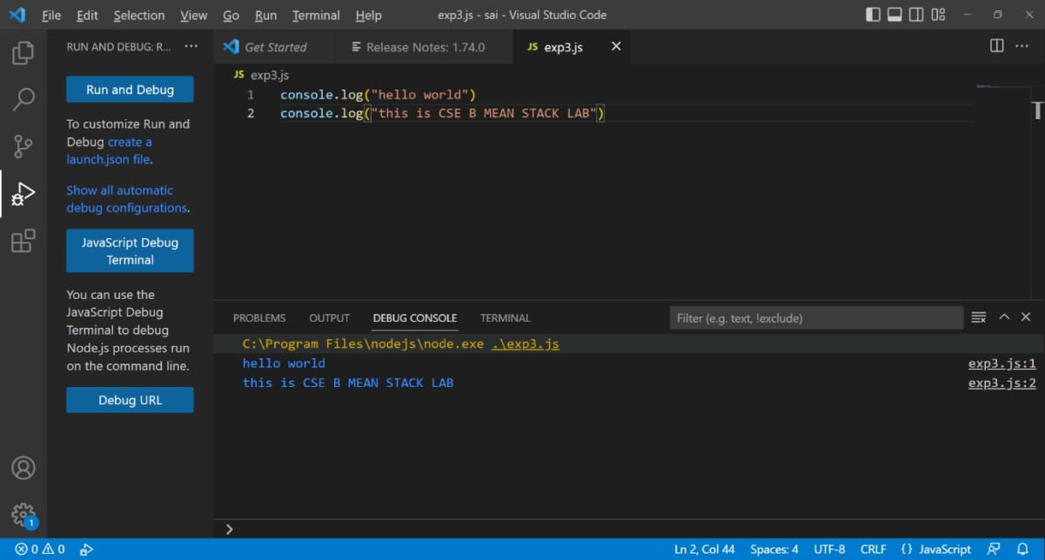

## Array:

An array is used to store a collection of data, but it is often more useful to think of an array as a collection of variables of the same type.

## Create Arrays in Nodejs:

We can create the arrays in nodejs with the following code. To create an empty array

var array = [];

### To create an array with elements

var arr = [ 'cat', 'goat', 'bat' ];

## Array Functions in Node js:

**Index:**

### Access the array, we can access the nodejs array using the index of the array, array index starts from 0. Index number is used along with the **[ ]** operator.

var arr = [ 'cat', 'goat', 'bat' ]; console.log(arr[0]) // prints cat console.log(arr[2]) // prints bat

##### INDEXOF:

indexOf method is used to return the first index of the element passed within the array or otherwise it will return -1 if the value is not found.

var arr = [ 'cat', 'dog', 'goat', 'mummy', 'goat' ]; console.log(arr) // prints 'cat', 'dog', 'goat', 'mummy', 'goat' var position = arr.indexOf("avatar");

console.log(position)

//prints -1 console.log(arr.indexOf("goat"))

//prints 2

## lastIndexOf() :

lastIndexOf method is used to return the last index of the element passed within the array or otherwise it will return -1 if the value is not found.

var arr = [ 'cat', 'dog', 'goat', 'cat']; console.log(arr) // prints 'cat', 'dog', 'goat', 'cat' var position = arr.lastIndexOf("avatar"); console.log(position)

//prints -1 console.log(arr.lastIndexOf("goat"))

//prints 3

## push function :

push() function helps to create an object inside the array,

const fruits = [];

fruits.push("banana", "apple", "peach"); console.log(fruits.length); // prints ‘3’

console.log(fruits); //prints "banana", "apple", "peach"; fruits.push("grapes");

console.log(fruits); //prints 'banana', 'apple', 'peach', 'grapes' console.log(fruits.pop()); // prints ‘

## pop function :

pop() function removes the element from the end of the array. pop() does not accept any parameter

var arr = [ 'cat', 'dog', 'goat' ]; console.log(arr) // prints 'cat', 'dog', 'goat'

arr.pop()

console.log(arr) // prints 'cat', 'dog'

## unshift function :

unshift() method in arrays is used to insert an element at the beginning of the array

var arr = [ 'cat', 'dog', 'goat' ]; console.log(arr) // prints 'cat', 'dog', 'goat' arr.unshift("pug")

console.log(arr) // prints 'pug', 'cat', 'dog', 'goat'

## shift function :

shift() method is used to remove the element from the beginning of the array, shift() functions do not accept any parameter. pop removes the element from the end of the array

var arr = [ 'cat', 'dog', 'goat' ]; console.log(arr) // prints 'cat', 'dog', 'goat' arr.shift()

console.log(arr) // prints 'dog', 'goat'

## sort() function in nodejs:

sort method is used to arrange the elements of the array in ascending order

var arr = [ 'cat', 'goat', 'dog','mummy', 'goat' ]; console.log(arr);

console.log(arr.sort());

## output:

[ 'cat', 'goat', 'dog', 'mummy', 'goat' ]

[ 'cat', 'dog', 'goat', 'goat', 'mummy' ]

## reverse() function in nodejs:

reverse() function is used to reverse the order of the array such that the first element becomes the last and the last element becomes the first. reverse() function does not accept any parameter.

var arr = [ 1, 9, 3 ];

console.log(arr) // prints 1, 9, 3 arr.reverse()

console.log(arr) // prints 3, 9, 1

## concat()

concat method is used to join two arrays and returns a new array consisting of the elements of both the arrays one after another**.**

arr = ['jack fruit','grape'];

arr2 = ['mango','kiwi','apple']; console.log(arr); console.log(arr2);

var new_arr = arr.concat(arr2); console.log(new_arr);

//prints 'jack fruit','grape','mango','kiwi','apple'

arr = ['jack fruit','grape'];

arr2 = ['mango','kiwi','apple']; console.log(arr);

console.log(arr2);

var new_arr = arr2.concat(arr);

console.log("concatinated array is ", new_arr);

console.log("concatinated array after soting is" , new_arr.sort());

## output:

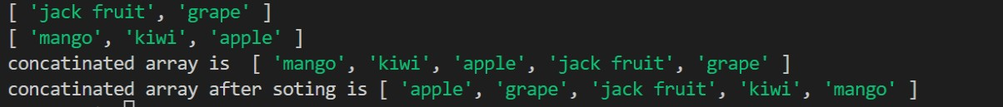

**forEach() function :**

The forEach() function works only on collections and is used to loop through each key in an array. An array is also one of the collection

// prints banana apple

const fruits = [];

fruits.push("banana", "apple", "peach"); fruits.forEach(function(i) {

console.log(i);

});

## PROGRAM 4:

**Aim : Write node.js program to create, access, modify JSON Object.**

[JSON](https://www.geeksforgeeks.org/javascript-json/) or JavaScript Object Notation is a light weight, text-based data interchange format.

* + JSON is like XML, it is one of the way of exchanging information between applications.
  + This format of data is widely used by web applications/APIs to communicate with each other.

## Reading a JSON file:

* **Method 1:**

**Using require method:** The simplest method to read a JSON file is to require it in a node.js file using require() method.

## Syntax:

const data = require('path/to/file/filename');

## Example:

Create a **users.json** file in the same directory where **index.js** file present. Add following data to the json file.

## users.json file:

[

{

"name": "Harber", "age": 30,

"language": ["MEAN", "Express", "NodeJS"]

},

{

"name": "Alex Young", "age": 35,

"language": ["Angular", "MEAN", "AngularJS"]

},

{

"name": "John", "age": 21,

"language": ["JavaScript", "PHP", "Python"]

},

{

"name": "Smith", "age": 25,

"language": ["PHP", "Go", "JavaScript"]

}

]

## index.js file:

const users = require("./users"); console.log(users);

>>>run the file using the command: node index.js

## OUTPUT:

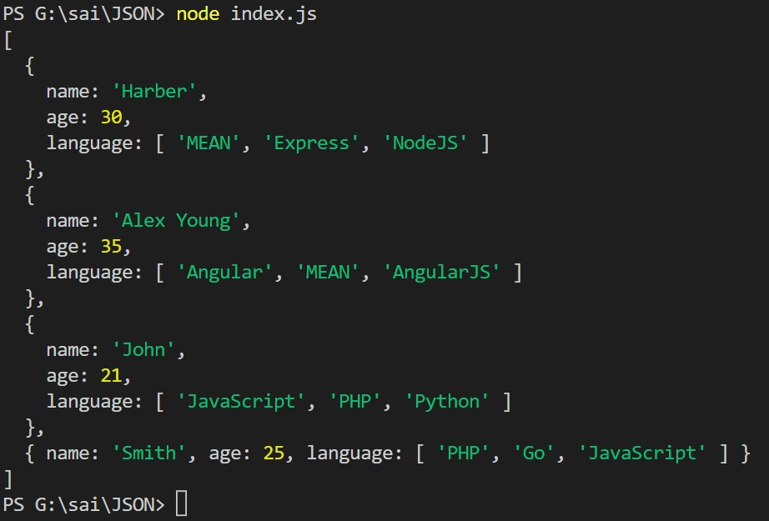

**Method 2:**

## Using the fs module:

We can also use node.js **fs** module to read a file. The fs module returns a file content in string format so we need to convert it into JSON format by using **JSON.parse()** in-built method.

## index.js file:

const fs = require("fs");

// Read users.json file

fs.readFile("users.json", function(err, data) {

// Check for errors if (err) throw err;

// Converting to JSON

const users = JSON.parse(data);

console.log(users); // Print users

});

const fs = require("fs");

// Read users.json file

fs.readFile("users.json", function(err, data) {

// Check for errors if (err) throw err;

// Converting to JSON

const users = JSON.parse(data);

console.log(users); // Print users

});

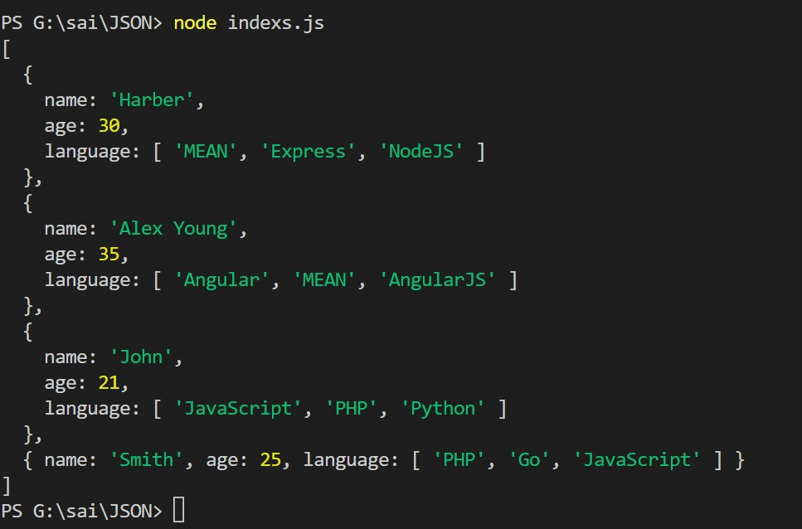

## Writing to a JSON file:

We can write data into a JSON file by using the node.js **fs** module. We can use **writeFile** method to write data into a file.

## Syntax:

fs.writeFile("filename", data, callback);

const fs = require("fs");

// STEP 1: Reading JSON file const users = require("./users");

// Defining new user let user = {

name: "New User", age: 30,

language: ["PHP", "Go", "JavaScript"]

};

// STEP 2: Adding new data to users object

users.push(user);

// STEP 3: Writing to a file

fs.writeFile("users.json", JSON.stringify(users), err => {

// Checking for errors if (err) throw err;

console.log("Done writing"); // Success

});

## OUTPUT:

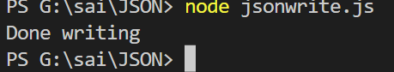

>>>Now check your **users.json** file it will looks something like below:

[{"name":"Harber","age":30,"language":["MEAN","Express","NodeJS"]},{"name":"Alex

Young","age":35,"language":["Angular","MEAN","AngularJS"]},{"name":"John","age":21,"langua

ge":["JavaScript","PHP","Python"]},{"name":"Smith","age":25,"language":["PHP","Go","JavaScri pt"]},{"name":"New

User","age":30,"language":["PHP","Go","JavaScript"]},{"name":"nagamani","age":30,"language"

:["MEAN","SRGEC","MEANSTACK"]},{"name":"nagamani","age":30,"language":["MEAN","SRGEC ","MEANSTACK"]}]

## PROGRAM 5:

**Aim:Install Express and Create an Application. INSTALLATION**.

C:\Users\cse>npm install express added 57 packages in 10s

7 packages are looking for funding run `npm fund` for details

C:\Users\cse>npm install express –save up to date, audited 58 packages in 827ms 7 packages are looking for funding

run `npm fund` for details found 0 vulnerabilities

## packages:

C:\Users\cse>npm install body-parser –save

added 2 packages, changed 2 packages, and audited 60 packages in 1s 7 packages are looking for funding

run `npm fund` for details found 0 vulnerabilities

C:\Users\cse>npm install cookie-parser –save added 2 packages, and audited 62 packages in 1s 7 packages are looking for funding

run `npm fund` for details found 0 vulnerabilities

C:\Users\cse>npm install multer –save

added 19 packages, and audited 81 packages in 3s 8 packages are looking for funding

run `npm fund` for details

found 0 vulnerabilities C:\Users\cse>d:

D:\20-5h8>code **. EXAMPLE CODE:**

var express = require('express'); var app = express();

app.get('/', function (req, res) { res.send('Hello!!!');

})

var server = app.listen(8000, function () { var host = server.address().address

var port = server.address().port

console.log("Example app listening at http://%s:%s", host, port)

})

## OUTPUT:

PS C:\20481A0580> node exp5.js Example app listening at http://:::8000

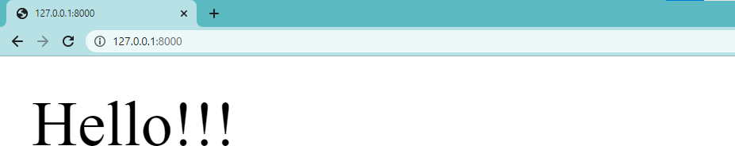

## INSTALLATION OF EXPRESS:

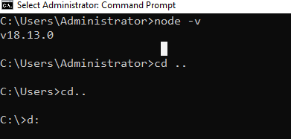

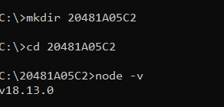

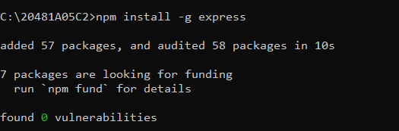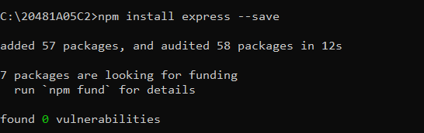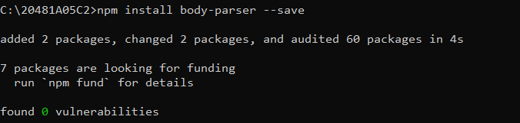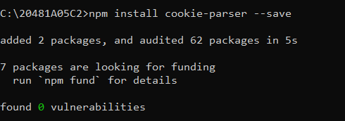

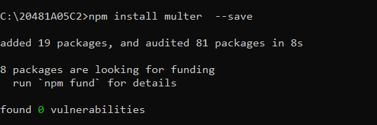

**EXPERIMENT-6:**

**Aim**: Perform CRUD operations using ExpressJS and mongoDB

## Description:

1. Check whether node js is installed or not:

##### D:\>node -v

1. Install mongoDB
2. Install express

##### Eg: D:\expressjs\>

1. Install mongoose using command prompt or visual studios in same folder where express is installed.

##### npm instal[lmongoose@6.9.0](mailto:mongoose@6.9.0)

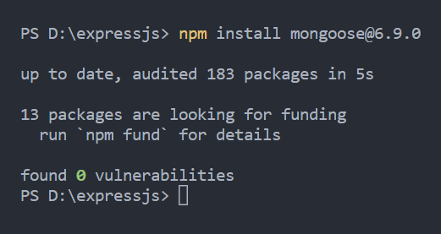

**mongoose:**

It is an Object Data Modelling (OBM) library for MongoDB.

1. Save all the programs in the same folder and to run the code:

**D:\expressjs\> node progname.js**

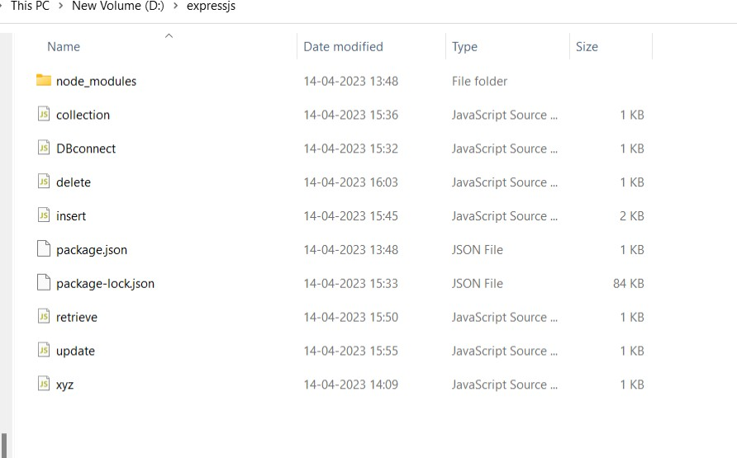

## DBconnect.js:

To create and connect to a database “demo”.

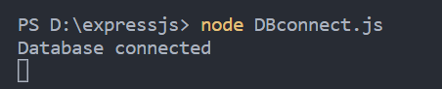

var mongoose=require("\mongoose"); mongoose.set("strictQuery",false); mongoose.connect("mongodb://127.0.0.1:27017/demo")

.then(() =>console.log("Database connected"))

.catch((Error) =>console.log(Error));

## collection.js:

To create a collection “demo1” in “demo” database.

var mongoose=require("mongoose"); mongoose.set("strictQuery",false); mongoose.connect("mongodb://127.0.0.1:27017/demo")

.then(() =>console.log("Database connected"))

.catch((err) =>console.log("Error")); const demo123=mongoose.Schema({

name:String, ID:Number, address:String,

});

const CustomerData=mongoose.model("demo1",demo123); console.log("Collection created");

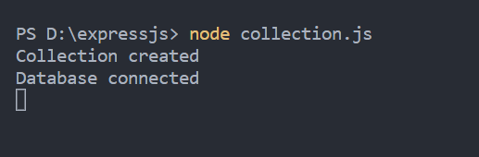

In mongodb compass:

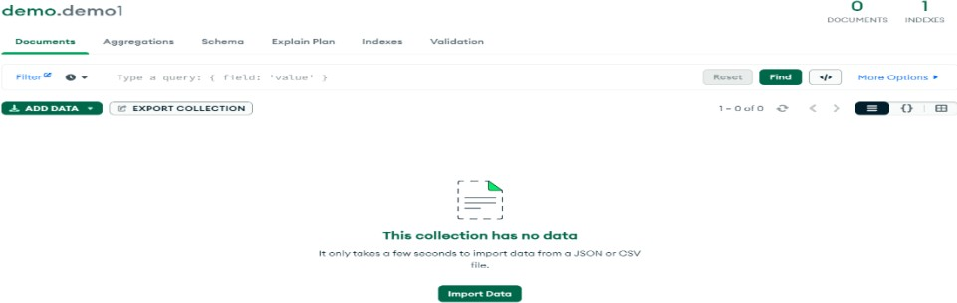

## Insert.js:

var mongoose=require("mongoose"); mongoose.set("strictQuery",false); mongoose.connect("mongodb://127.0.0.1:27017/demo")

.then(() =>console.log("Database connected"))

.catch((Error) =>console.log("Error")); const demo123=mongoose.Schema({

name:String, ID:Number, address:String,

});

const CustomerData=mongoose.model("demo1",demo123); console.log("Collection created");

const c1=new CustomerData({ name:"Anand",

ID:"101",

address:"vijayawada",

});

const c2=new CustomerData({ name:"jaahnavi", ID:"102",

address:"gudivada",

});

const c3=new CustomerData({ name:"priya",

ID:"102",

address:"guntur",

});

const c4=new CustomerData({ name:"Sai",

ID:"102",

address:"vijayawada",

});

const c5=new CustomerData({ name:"AnandSai",

ID:"105",

address:"vizag",

});

c1.save();

c2.save();

c3.save();

c4.save();

c5.save();

console.log("Data Inserted sucessfully");

**Retrieve.js**

var mongoose=require("mongoose"); mongoose.set("strictQuery",false); mongoose.connect("mongodb://127.0.0.1:27017/demo")

.then(() =>console.log("Database connected"))

.catch((Error) =>console.log("Error")); const demo123=mongoose.Schema({

name:String, ID:Number, address:String,

});

const CustomerData=mongoose.model("demo1",demo123);

const CustomerDisplay=async () => { const r=await CustomerData.find();

/* CustomerData.find({name:'RAMESH'}); for single filed retrival */

console.log(r);

};

CustomerDisplay();

Output:

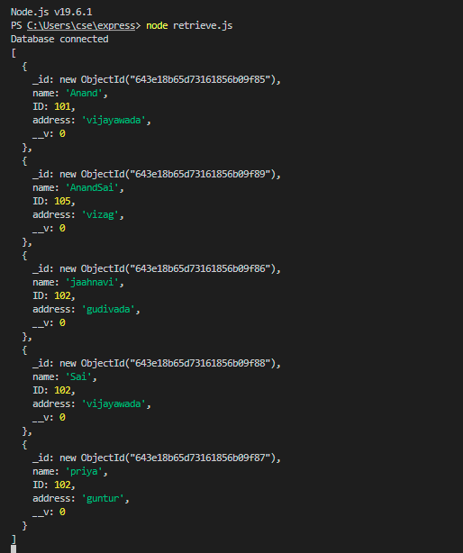

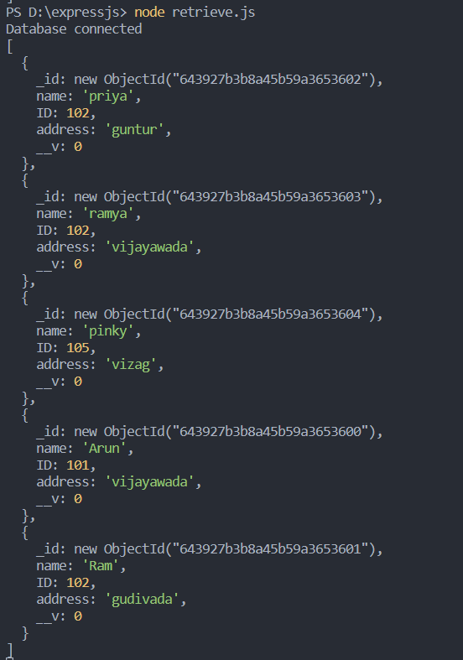

## Update.js

var mongoose=require("mongoose"); mongoose.set("strictQuery",false); mongoose.connect("mongodb://127.0.0.1:27017/demo")

.then(() =>console.log("Database connected"))

.catch((Error) =>console.log("Error")); const demo123=mongoose.Schema({

name:String, ID:Number, address:String,

});

const CustomerData=mongoose.model("demo1",demo123); const CustomerDisplay=async () => {

const result=await CustomerData.updateOne(

{ name:"ramya" },{ $set: { ID:105 } }

);

console.log(result);

};

CustomerDisplay();

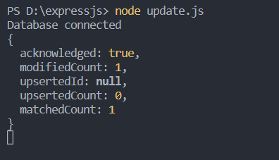

In mongodb compass:

## Delete.js

**deleteOne:**

varmongoose=require("mongoose"); mongoose.set("strictQuery",false); mongoose.connect("mongodb://127.0.0.1:27017/demo")

.then(() =>console.log("Database connected"))

.catch((*Error*) =>console.log("Error")); constdemo123=mongoose.Schema({

name:String, ID:Number, address:String,

});

constCustomerData=mongoose.model("demo1",demo123); constCustomerDisplay=async () => {

constresult=awaitCustomerData.deleteOne({ ID:102 }); console.log(result);

};

CustomerDisplay();

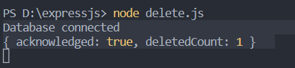

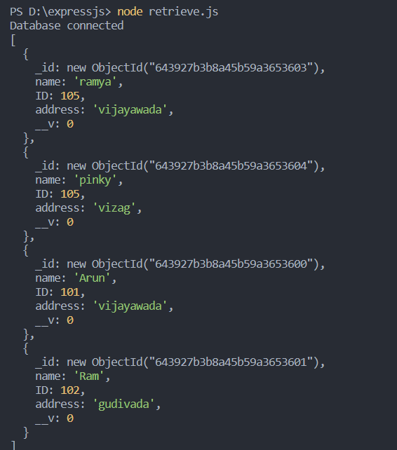

## deleteMany:

var mongoose=require("mongoose"); mongoose.set("strictQuery",false); mongoose.connect("mongodb://127.0.0.1:27017/demo")

.then(() =>console.log("Database connected"))

.catch((Error) =>console.log("Error")); const demo123=mongoose.Schema({

name:String, ID:Number, address:String,

});

const CustomerData=mongoose.model("demo1",demo123); const CustomerDisplay=async () => {

const result=await CustomerData.updateOne(

{ name:"ramya" },{ $set: { ID:105 } }

);

console.log(result);

};

CustomerDisplay();

**PROGRAM-7:**

## Aim:Write a typescript program to work with different types of variables

**,functions and run the programs using node environment. Installation of TypeScript:**

## Step-1:

Install Node.js. It is used to setup TypeScript on our local computer and verify the installation is done or not by the command

**node -v**



## Step2:

Install TypeScript,we use the following commands npm install typescript - -save-dev

npm install typescript -g

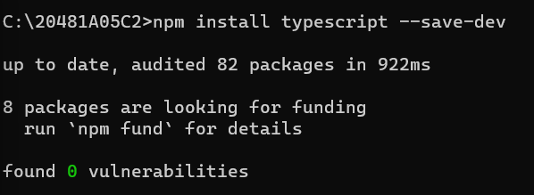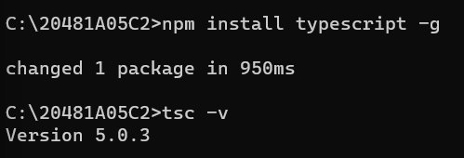

## Example Program:

**exp7.ts**

function student(name:String,branch:String,cgpa:number)

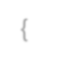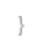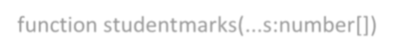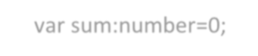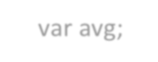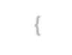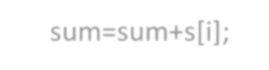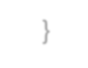

{

console.log("student name:"+name) console.log("student branch:"+branch) console.log("student cgpa:"+cgpa)

}

function studentdefault(name:string="ravi",branch:string="cse",cgpa:number=95)

{

console.log("student name:"+name) console.log("student branch:"+branch) console.log("student cgpa:"+cgpa)

}

function studentdetails(name:string,rollno:string,sgpa:number)

{

console.log("student name:"+name) console.log("student rollno:"+rollno) console.log("student sgpa:"+sgpa)

}

function studentmarks(...s:number[])

{

var i;

var sum:number=0; var avg; for(i=0;i<s.length;i++)

{

sum=sum+s[i];

}

console.log("total marks:"+sum) console.log("Average marks:"+sum/(s.length))

}

student("dinesh","cse",89) studentdefault() studentdetails("vamsi","cse",85) studentmarks(94,97,99,66,89,85)



studentdetails("sandeep","512",80)

studentmarks(100, 67, 83, 76, 98);

## Example Program: Exp7.js



function student(name, branch, cgpa) {



console.log("student name:" + name);



console.log("student branch:" + branch);



console.log("student cgpa:" + cgpa);

}



function studentdefault(name, branch, cgpa) {



if (name === void 0) { name = "ravi"; }



if (branch === void 0) { branch = "cse"; }



if (cgpa === void 0) { cgpa = 95; }



console.log("student name:" + name);



console.log("student branch:" + branch);



console.log("student cgpa:" + cgpa);

}



function studentdetails(name, rollno, sgpa) {



console.log("student name:" + name);



console.log("student rollno:" + rollno);



console.log("student sgpa:" + sgpa);

}



function studentmarks() {



var s = [];



for (var _i = 0; _i < arguments.length; _i++) {



s[_i] = arguments[_i];

}



var i;



var sum = 0;



var avg;



for (i = 0; i < s.length; i++) {



sum = sum + s[i];

}



console.log("total marks:" + sum);



console.log("Average marks:" + sum / (s.length));

}



student("dinesh", "cse", 89);



studentdefault();



studentdetails("vamsi", "cse", 85);



studentmarks(94, 97, 99, 66, 89, 85);



studentdetails("sandeep", "512", 80);



studentmarks(100, 67, 83, 76, 98);



**output:**

D:\dinesh>tsc exp7.ts D:\dinesh>node exp7.js student name:dinesh

student branch:cse student cgpa:89

student name:ravi student branch:cse student cgpa:95

student name:vamsi student rollno:cse

student sgpa:85 total marks:530

Average marks:88.33333333333333 student name:sandeep

student rollno:512 student sgpa:80

total marks:424 Average marks:84.8

## PROGRAM:8

**Aim:Write a typescript program to work with classes.**

## CLASSES IN TYPESCRIPT:

In object-oriented programming languages like Java, classes are the fundamental entities which are used to create **reusable** components. It is a group of objects which have common properties. In terms of OOPs, a class is a **template** or **blueprint** for creating objects. It is a logical entity.

##### A class definition can contain the following properties:

* **Fields:** It is a variable declared in a class.
* **Methods:** It represents an action for the object.
* **Constructors:** It is responsible for initializing the object in memory.
* **Nested class and interface:** It means a class can contain another class.

TypeScript is an Object-Oriented JavaScript language, so it supports object-oriented programming features like classes, interfaces, polymorphism, data-binding, etc. JavaScript **ES5** or **earlier version** did not support classes. TypeScript support this feature from **ES6** and **later version**. TypeScript has **built-in** support for using classes because it is based on ES6 version of JavaSript. Today, many developers use class-based object-oriented programming languages and compile them into JavaScript, which works across all major browsers and platforms.

Syntax to declare a class:

class **<class_name>**{ field;

method;

}

The TypeScript compiler converts class into JavaScript code.

## Creating an object of class:

A class creates an object by using the **new** keyword followed by the **class name**. The new keyword allocates memory for object creation at runtime. All objects get memory in heap memory area. We can create an object as below.

## Syntax:

let object_name = new class_name(parameter)

1. new keyword: it is used for instantiating the object in memory.
2. The right side of the expression invokes the constructor, which can pass values.

## Object Initialization:

Object initialization means storing of data into the object. There are three ways to initialize an object. These are:

1. By reference variable
2. By method
3. By constructor **PROGRAM: exp8.ts**

class Student

{

studcode:number; studname:string; grade:string;

constructor(code:number,name:string,grade:string){ this.studname=name;

this.studcode=code; this.grade=grade;

}

display():void{

console.log("name:",this.studname); console.log("code:",this.studcode); console.log("grade:",this.grade);

}

}

let obj1=new Student(9491825377,'dinesh','A+'); obj1.display();

## exp8.js:

var Student = /** @class */ (function () { function Student(code, name, grade) {

this.studname = name; this.studcode = code;

this.grade = grade;

}

Student.prototype.display = function () { console.log("name:", this.studname); console.log("code:", this.studcode); console.log("grade:", this.grade);

};

return Student;

}());

var obj1 = new Student(9491825377, 'dinesh', 'A+'); obj1.display();

## OUTPUT:

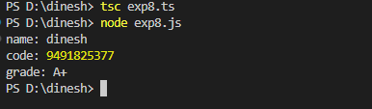

**PROGRAM-9**

Aim:Create a simple angular application using Angular CLI and TypeScript

## ANGULAR:

**Angular** is a front-end framework which is used to create web applications. It uses typescript by default for creating logics and methods for a class but the browser doesn’t know

typescript. Here webpack comes in picture, webpack is used to compile these typescript files

to JavaScript. In addition, there are so many configuration files you will need to run an angular project on your computer.

## ANGULAR CLI:

**Angular CLI** is a tool that does all these things for you in some simple commands. Angular CLI uses webpack behind to do all this process.

## Installation of Angular CLI:

You can use the Angular CLI to create projects, generate application and library code, and perform a variety of ongoing development tasks such as testing, bundling, and deployment.

To install the Angular CLI, open a terminal window and run the following command:

## npm install -g @angular/cli

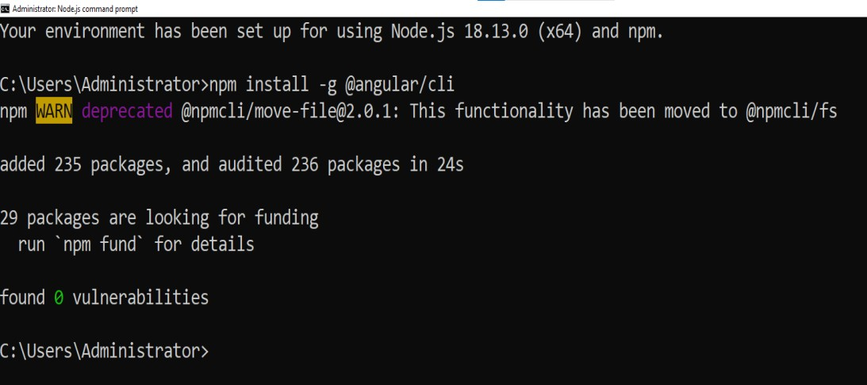

**Create a workspace and initial application**

You develop apps in the context of an Angular [workspace](https://angular.io/guide/glossary#workspace).

To create a new workspace and initial starter app:

* 1. Run the CLI command ng new and provide the name my-app, as shown here:

##### ng new my-app

* 1. The ng new command prompts you for information about features to include in the initial app. Accept the defaults by pressing the Enter or Return key.

The Angular CLI installs the necessary Angular npm packages and other dependencies. This can take a few minutes.

The CLI creates a new workspace and a simple Welcome app, ready to run.

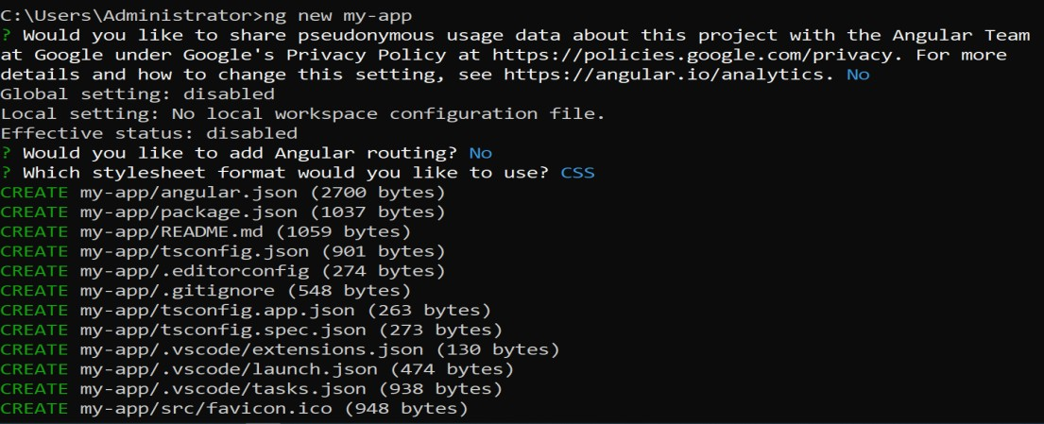

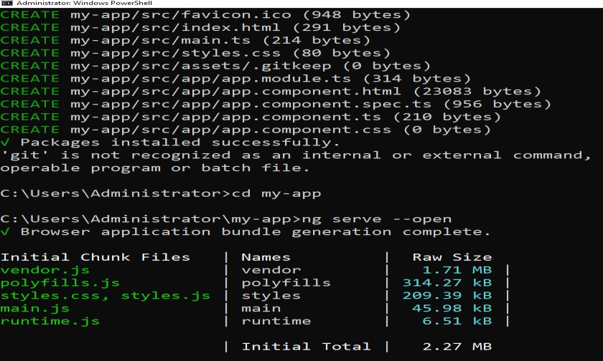

## Run the application:

The Angular CLI includes a server, for you to build and serve your app locally.

1. Navigate to the workspace folder, such as my-app.
2. Run the following command:

##### cd my-app

**ng serve –open**

The ng serve command launches the server, watches your files, and rebuilds the app as you make changes to those files.

The --open (or just -o) option automatically opens your browser to http://localhost:4200/. If your installation and setup was successful, you should see a page similar to the following.

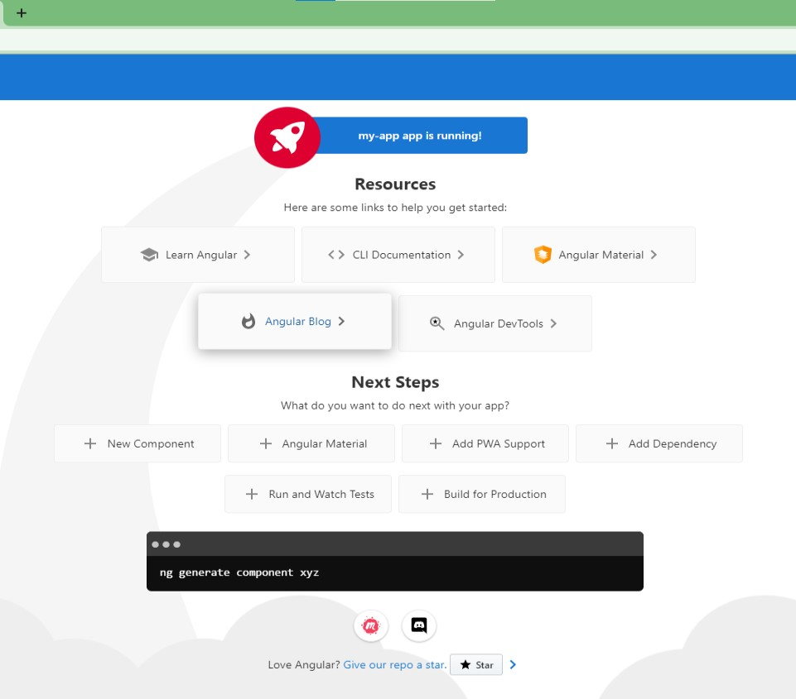

Application using TypeScript and Angular CLI:

VS code→File→Open Folder→Select the Folder→my app→src→app→app.component.html

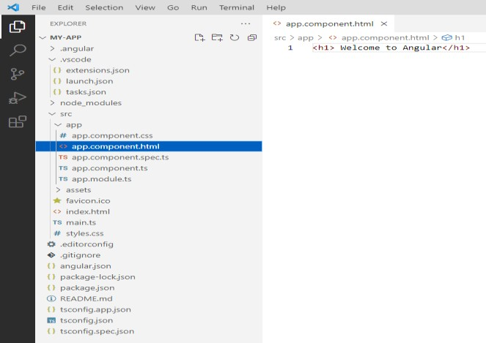

<h1> HELLO :) </h1>

Type ng serve –open in terminal

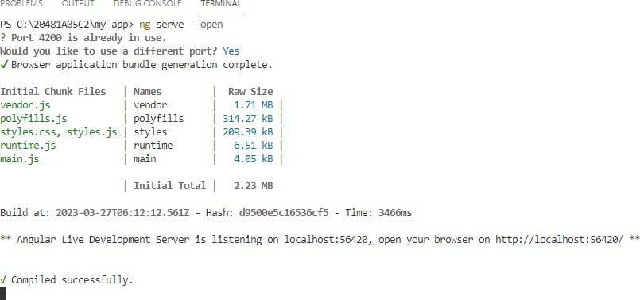

## OUTPUT:

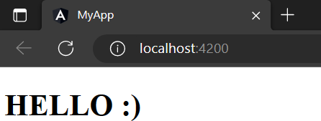

**Program No:**10 **Date:**

**Aim:** Create an angular application to work with components.

**Component:**

A Component in angular is a isolated entity that enables reuse and maintainability of code. Component encapsulate the data, logic, and HTML for a view - means everything user sees on screen.

Components are the main building block for Angular applications. Each component consists of:

* An HTML template that declares what renders on the page
* A Typescript class that defines behaviour
* A CSS selector that defines how the component is used in a template
* Optionally, CSS styles applied to the template

**Creating a component:**

The best way to create a component is with the Angular CLI. You can also create a component manually.

Creating a component using the Angular CLI To create a component using the Angular CLI:

1. From a terminal window, navigate to the directory containing your application.
2. Run the ng generate component <component-name> command, where <component- name> is the name of your new component.
3. ng g c <component-name>

By default, this command creates the following:

* A directory named after the component
* A component file, <component-name>.component.ts
* A template file, <component-name>.component.html
* A CSS file, <component-name>.component.css
* A unit test specification file, <component-name>.component.spec.ts Where <component-name> is the name of your component.

**Creating a component manually:**

Although the Angular CLI is the best way to create an Angular component, you can also create a component manually. This section describes how to create the core component file within an existing Angular project.

To create a new component manually:

1. Navigate to your Angular project directory.
2. Create a new file, <component-name>.component.ts.
3. At the top of the file, add the following import statement. import { [Component](https://angular.io/api/core/Component) } from '@angular/core';

After the import statement, add a @[Component](https://angular.io/api/core/Component) decorator. @Component({

})

Choose a CSS selector for the component and define the HTML template that the component uses to display information. In most cases, this template is a separate HTML file.

@[Component](https://angular.io/api/core/Component)({

selector: 'app-component-overview',

templateUrl: './component-overview.component.html',

})

Every component requires a CSS *selector*. A selector instructs Angular to instantiate this component wherever it finds the corresponding tag in template HTML.

A template is a block of HTML that tells Angular how to render the component in your application. Define a template for your component in one of two ways: by referencing an external file, or directly within the component.

@[Component](https://angular.io/api/core/Component)({\

selector: 'app-component-overview', template: '<h1>Hello World!</h1>

, })

Select the styles for the component's template. In most cases, you define the styles for your component's template in a separate file.

@Component({

selector: 'app-component-overview',

templateUrl: './component-overview.component.html', styleUrls: ['./component-overview.component.css']

})

Add a class statement that includes the code for the component. export class ComponentOverviewComponent {

#code

}

**Program:**

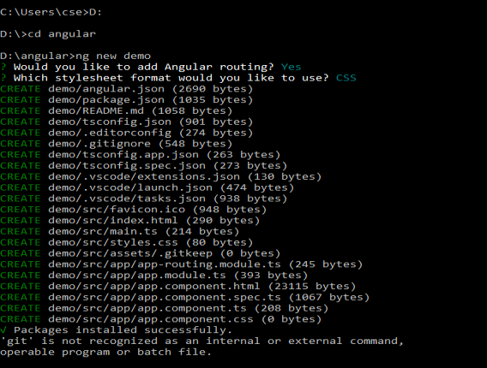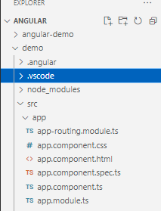

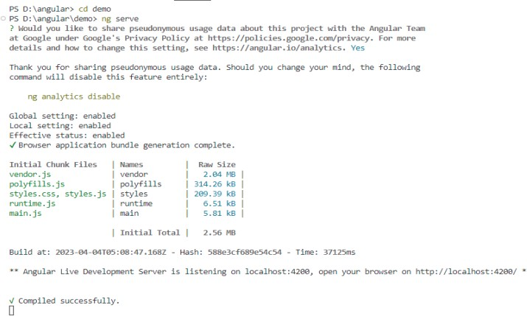

## Output:

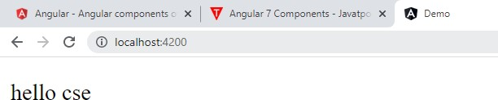

**Program No:**11

**Aim:**Create an angular application to work with pipes.

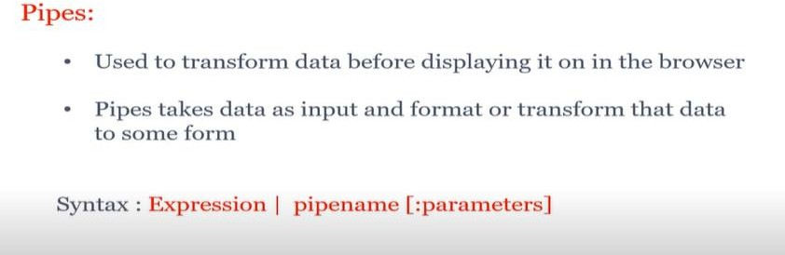

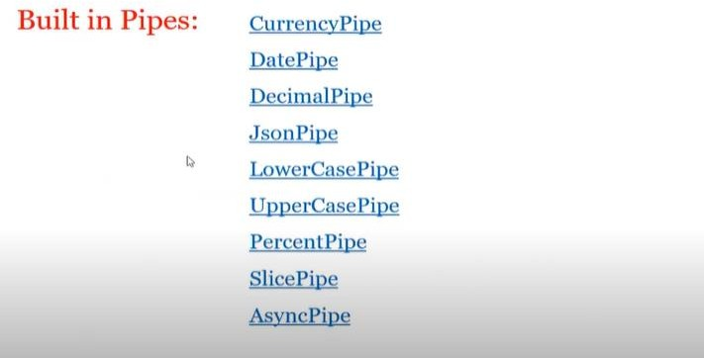

## Program1:

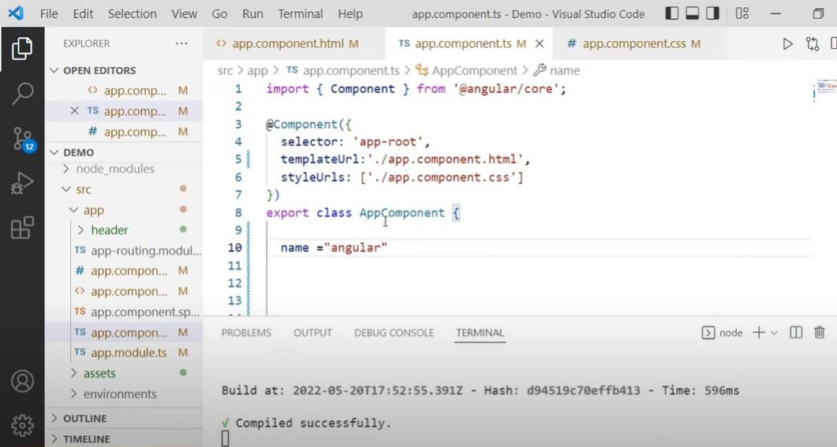

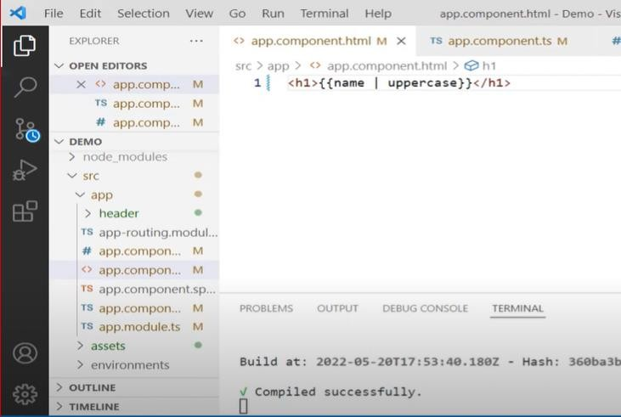

**Output:**

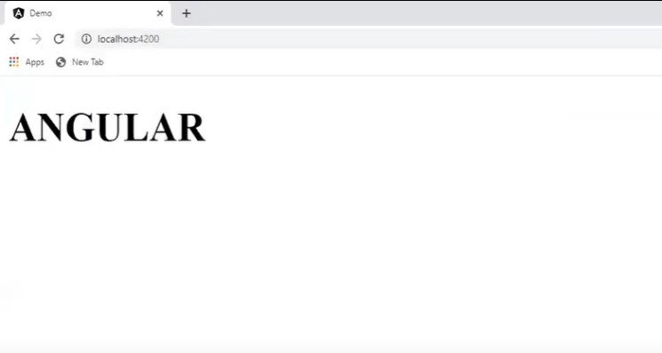

## Program2:

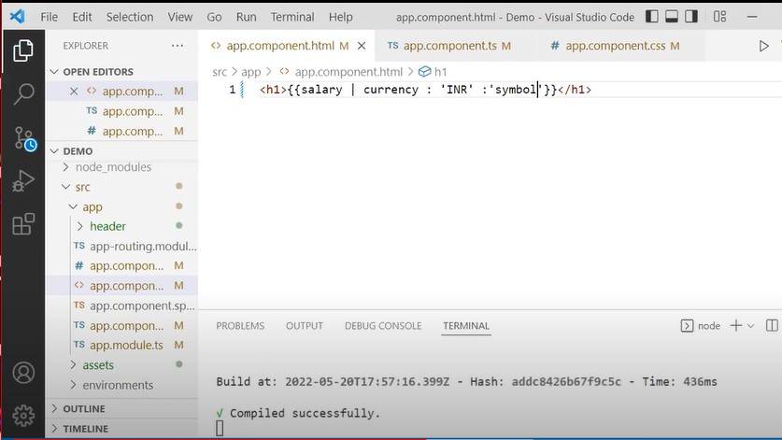

**Output:**

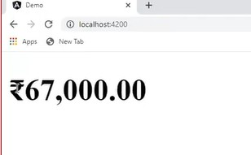

## Program3:

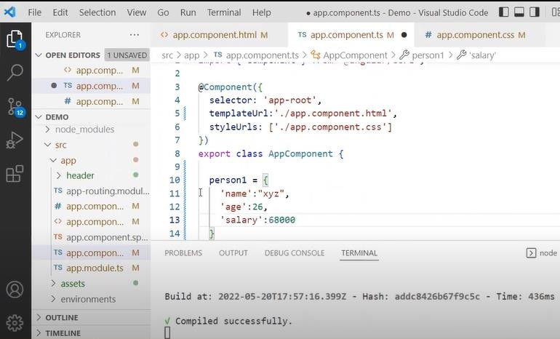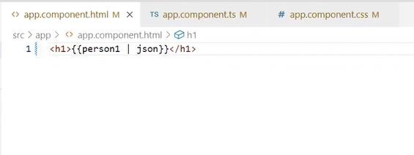

**Output:**

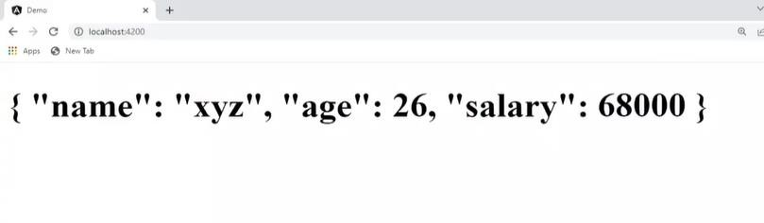

## Creating custom pipes:

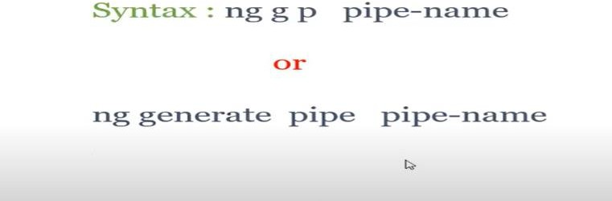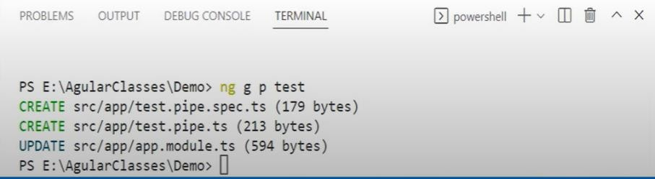

**Program4:**

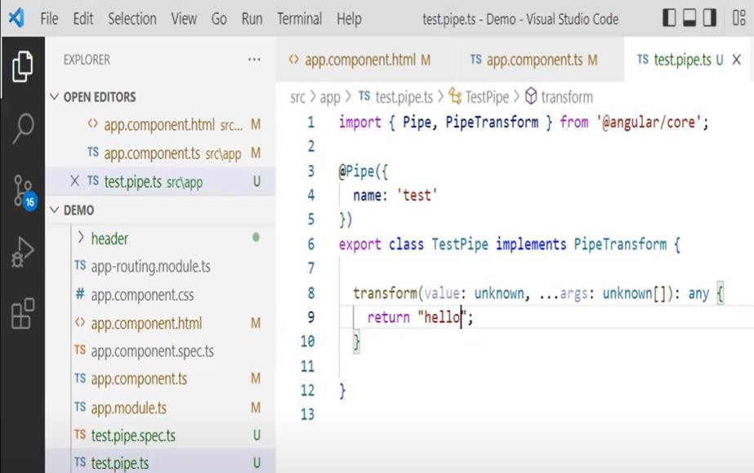

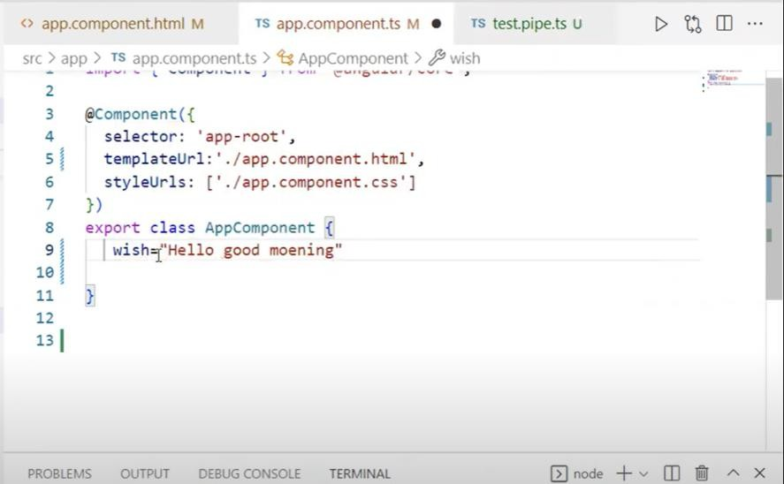

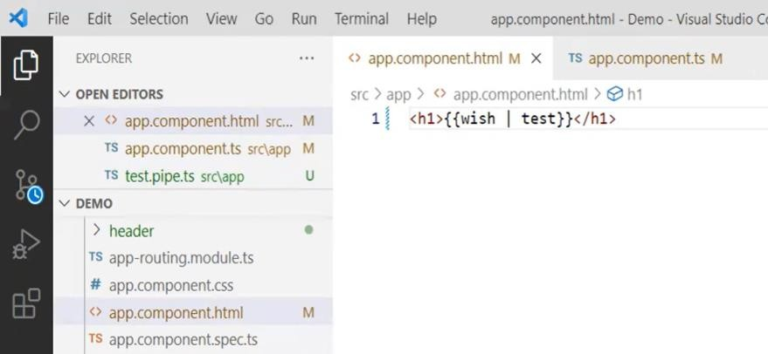

## Output:

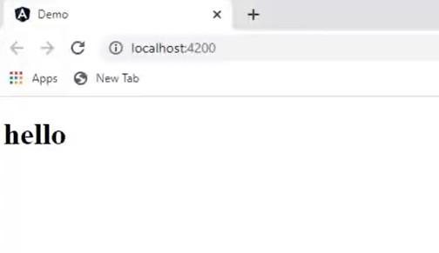

**Program No:**12 **Date:**

**Aim:** Create an angular application to work with directives.

## What is Angular JS.!?

* AngularJS is a **JavaScript frameworkwritten in JavaScript**. It can be added to an HTML page with a <script> tag.
* AngularJS extends HTML attributes with **Directives**, and binds data to HTML with **Expressions**.
* AngularJS is distributed as a JavaScript file, and can be added to a web page with a script tag
  + <script src="https://ajax.googleapis.com/ajax/libs/angularjs/1.6.9/angular.min.js "></script>

Before you study AngularJS, you should have a basic understanding of:

* [HTML](https://www.w3schools.com/html/default.asp)
* [CSS](https://www.w3schools.com/css/default.asp)
* [JavaScript](https://www.w3schools.com/js/default.asp)

## AngularJS History:

* AngularJS version 1.0 was released in 2012.
* MiškoHevery, a Google employee, started to work with AngularJS in 2009.
* The idea turned out very well, and the project is now officially supported by Google.

## AngularJS Extends HTML:

* AngularJS extends HTML with **ng-directives**.
* The **ng-app** directive defines an AngularJS application.
* The **ng-model** directive binds the value of HTML controls (input, select, textarea) to application data.
* The **ng-bind** directive binds application data to the HTML view.

## AngularJS Directives:

* As you have already seen, AngularJS directives are HTML attributes with an **ng** prefix.
* The **ng-init** directive initializes AngularJS application variables. Now let us try to understand about Directives briefly---

What is an Angular Directive?

* + Directives are the functions which will execute whenever Angular compiler finds it**.**
  + Angular Directives enhance the capability of HTML elements by attaching custom behaviors to the DOM.
  + From the core concept, Angular directives are categorized into three categories.

##### Attribute Directives

* 1. **Structural Directives**

##### Components

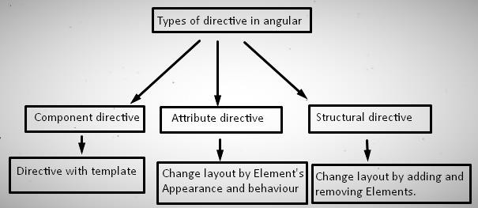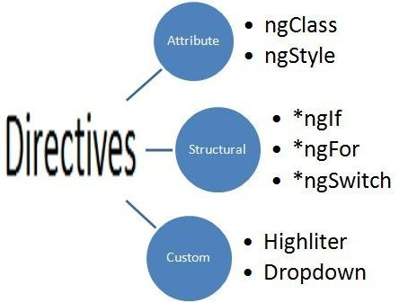

The ng-app directive initializes an AngularJS application. The ng-init directive initializes application data.

The ng-model directive binds the value of HTML controls (input, select, textarea) to application data.

## Program1:

<!DOCTYPEhtml>

<html>

<scriptsrc="https://ajax.googleapis.com/ajax/libs/angularjs/1.6.9/angular.min.js"></script>

<body>

<div ng-app=""ng-init="firstName='MEAN STACK'">

<p>Input something in the input box:</p>

<p>Name: <inputtype="text"ng-model="firstName"></p>

<p>You wrote: {{ firstName }}</p>

</div>

</body>

</html>

##### Output:

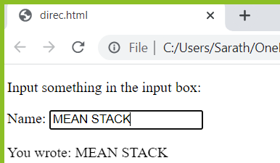

The {{ firstName }} expression, in the example above, is an AngularJS data binding expression. The ng-repeat directive repeats an HTML element:

## Program2:

<!DOCTYPEhtml>

<html>

<scriptsrc="https://ajax.googleapis.com/ajax/libs/angularjs/1.6.9/angular.min.js"></script>

<body>

<divng-app=""ng-init="names=['MEAN','FSAD','MERN']">

<p>Looping with ng-repeat:</p>

<ul>

<ling-repeat="x in names">{{ x }}</li>

</ul>

</div>

</body>

</html>

**Output:**

